MY SCHOOL BOOK
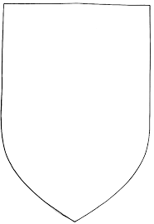

My name is …………………………..
My grade is ………………………….
My school’s name is …………………………………………….
My English teacher is ………………………………………….
My English classroom is Room .................

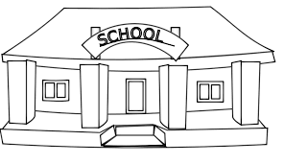

Map of my school
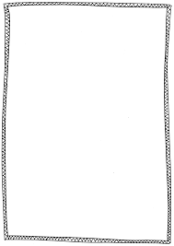
Description of my school (numbers of teachers, numbers of classrooms, is there a playground ? , a sports field ? , a drama hall ? , an elevator ?, ….)
……………………………………………………………………………………………………………………………………………………………………………………………………………………………………………………………………………………………………………………………………………………………………………………………………………………………………………………………………
…………………………………………………………………………………………
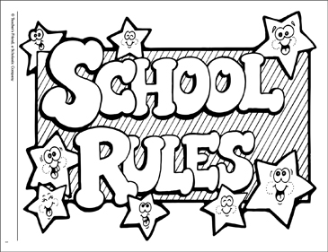

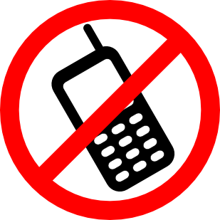



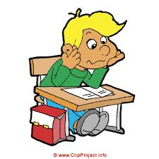



MY SCHOOL UNIFORM

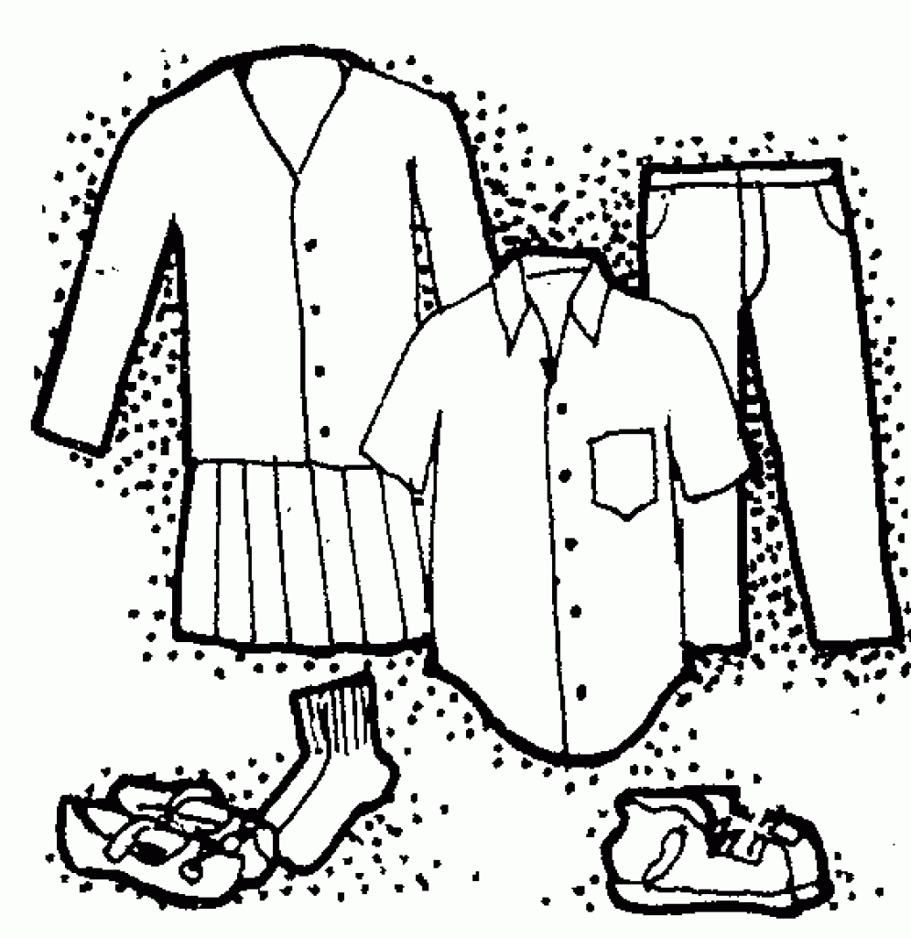

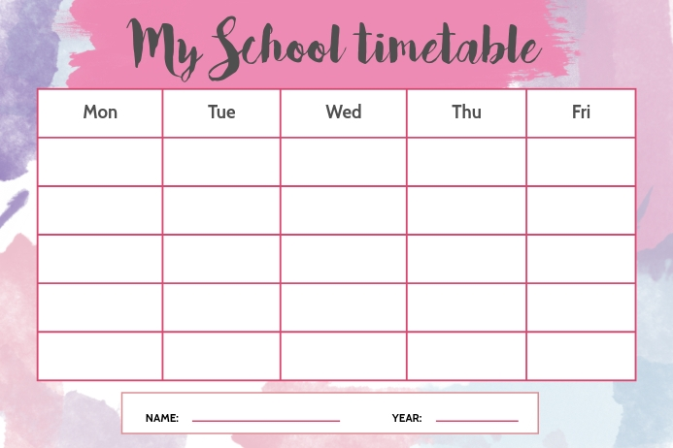

On Mondays, I start at …………………………….
On Tuesdays, I have …………………. periods.
On Wednesdays, I finish at ……………

My favorite day is ………………………………. because ………………………………
……………………………………………………………………………

I have English on …………………. , …………………… , …………… and ………...…..

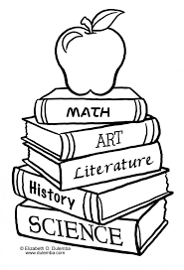
MY SUBJECTS

I love ………………………….. because…………….
…………………………………………………………..

I don’t like ……………………………….. because …………………….
……………………………………………………………………………………..

I like …………………………. because …………………..………………….
…………………………………………………………………………………………

I hate …………………….. because ………………………………………..
……………………………………………………………………………………….

